****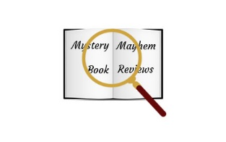

**If you have never said "Excuse me" to a parking meter or bashed your shins on a fireplug, you are probably wasting too much valuable reading time. ~Sherri Chasin Calvo**

**Mystery Mayhem Book Reviews is reminds you that your adventures were paused here.**

**“I hope you're pleased with yourselves. We could all have been killed - or worse, expelled.” -Hermione Granger**

**“Outside of a dog, a book is man’s best friend. Inside of a dog it’s too dark to read.” ~Attributed to Groucho Marx**



**Book Reviewers Wanted!**

Do you like reading? If so, would you like the opportunity to be recognized just for saying how you feel about the book you just finished plus getting the chance to get free copies of books just for reviewing them? If said yes, join our EXCLUSIVE reviewers program! Go to bit.ly/mysterymbr to join and for more information! Only 10 spots left, and they are filling up quickly!

Do you like reading? If so, would you like the opportunity to be recognized just for saying how you feel about the book you just finished plus getting the chance to get free copies of books just for reviewing them? If said yes, join our EXCLUSIVE reviewers program! Go to bit.ly/mysterymbr to join and for more information! Only 10 spots left, and they are filling up quickly!

**Book Reviewers Wanted!**

Do you like reading? If so, would you like the opportunity to be recognized just for saying how you feel about the book you just finished plus getting the chance to get free copies of books just for reviewing them? If said yes, join our EXCLUSIVE reviewers program! Go to bit.ly/mysterymbr to join and for more information! Only 10 spots left, and they are filling up quickly!

**Book Reviewers Wanted!**

**Book Reviewers Wanted!**

Do you like reading? If so, would you like the opportunity to be recognized just for saying how you feel about the book you just finished plus getting the chance to get free copies of books just for reviewing them? If said yes, join our EXCLUSIVE reviewers program! Go to bit.ly/mysterymbr to join and for more information! Only 10 spots left, and they are filling up quickly!